Alone in the crowd: A computational social network model uncovering the clustering mechanisms of loneliness.

Bas D.L. Châtel

Rick Quax

Geeske Peeters

Jeroen Janssen

Rense Corten

Marcel G. M. Olde Rikkert

Vítor V. Vasconcelos

Abstract

Loneliness is quickly growing in our aging societies and has many adverse (mental) health effects, but is still insufficiently studied as a complex multicausal system outcome. Subjective loneliness is mostly studied as an individual pathology, leading to a lack of attention to network interactions. However, early network research has found that, like other conditions, subjective loneliness tends to cluster in social networks and explains this by social processes such as homophily (i.e., the increased propensity to befriend like-minded people) and induction (i.e., influencing others). Here, loneliness induction is explained by three pathways. First, the behavioral pathway states that loneliness can lead individuals to act less trusting and more hostile toward others, potentially harming relationships and perpetuating loneliness. Second, the cognitive pathway states that loneliness can arise from a discrepancy between the expectation and perception of one’s connection to their social network. Finally, the emotional contagion pathway states that individuals may experience a convergence of emotions through nonverbal communication.   
We develop an agent-based model to simulate these pathways and explore their interplay in forming loneliness clusters within social networks. This allows analysis of the effects of homophily on various combinations of inductive processes over time. The model replicates the empirical findings on clustering of loneliness and that individuals may increase not only the likelihood of their friends experiencing loneliness (first-degree) but also their friends’ friends (second-degree). The cognitive pathway turns out to be the most dominant predictor for this clustering. However the three induction pathways prove uninformative in disentangling causal mechanisms as these only contribute to loneliness clustering when a certain level of homophily already exists within the network. Our modeling study adds to the understanding on clustering of subjective loneliness and shows that the alleviation of health and wellbeing effects of loneliness in our aging societies cannot be realized by focusing on individual-level factors alone but may benefit from implementing social network dynamics of loneliness.

Human behavior, Mental health, Social influence, Homophily, Agent-based modeling

Introduction

Loneliness, defined as the unwelcome feeling of a gap between the social connections we want and the ones we have, is a complex multi-causal system [@kawachiSocialTiesMental2001; @luntPerceivedCausalStructure; @Salway2020-tj] with numerous adverse (mental) health effects [@hawkleyLonelinessMattersTheoretical2010; @jamesalexandercrewdsonEffectLonelinessElderly2016; @kawachiSocialTiesMental2001]. For example, it is associated with an increased risk of developing clinical dementia [@holwerdaFeelingsLonelinessNot2014], depression [@erzenEffectLonelinessDepression2018], and behaviors harmful to health [@lauderComparisonHealthBehaviours2006; @newallConsequencesLonelinessPhysical2012]. In the Netherlands, 20% of 55-year-olds and 62% of 95-year-olds experience moderate to severe loneliness [@campenKwetsbaarEenzaamRisico2018].

While subjective loneliness is often viewed as an individual-centric issue [@donbavandSimmelianTheoryStructural2021] distinct from social isolation (the objective complete absence or lack of sufficient social relationships), it is important to recognize that network-level factors do influence loneliness. Research suggests that lonely individuals tend to connect with other lonely individuals, indicating the role of network influences in loneliness. This phenomenon extends beyond direct connections,. This concept, known as the "three degrees of influence," was proposed by Christakis and Fowler in their work on the spread of various traits within social networks [@cacioppoAloneCrowdStructure2009; @christakisCollectiveDynamicsSmoking2008; @christakisSpreadObesityLarge2007; @fowlerDynamicSpreadHappiness2008]. The clustering of loneliness can exacerbate its detrimental effects on physical and mental well-being [@berkman2000social], as observed across different populations [@fridmanskiClusteringNewlyForming2020; @cacioppoAloneCrowdStructure2009]. Recognizing the network-level dynamics of loneliness sheds light on its potential amplification and highlights its significance in public health and social research.

However, the causal mechanisms underpinning the clustering of subjective loneliness are still not fully understood. One theoretical framework proposed by [@cacioppoAloneCrowdStructure2009] describes three sociopsychological processes that contribute to such clustering: homophily, induction, and shared environment.

* **Homophily** refers to the tendency of individuals to form connections with others that have similar attributes or characteristics [@mcphersonBirdsFeatherHomophily2001a; @neimeyerSimilarityAttractionLongitudinal1988].
* **Induction** refers to people influencing one another such that lonely individuals may contribute to the spread of loneliness in their immediate environment. Induction consists of three pathways: cognitive, behavioral, and emotional contagion. The cognitive pathway suggests that loneliness arises from a mismatch between individuals’ social network expectations and their actual social experiences [@peplauPerspectivesLoneliness1982; @rookPromotingSocialBonding1984; @wheelerLonelinessSocialInteraction1983]. The behavioral pathway posits that lonely individuals may behave in ways that decrease relationship quality with others, thereby increasing induction in their surroundings [@rotenbergLonelinessInterpersonalTrust1994; @yavuzerRelationshipsAmongstAggression2019]. The emotional contagion pathway proposes that nonverbal communication between individuals may lead to converging emotions [@hatfieldEmotionalContagion1993; @kiuruDepressionContagiousTest2012].
* **Shared environment** refers to connected individuals having similar exposures to factors contributing to loneliness [@sawirLonelinessInternationalStudents2008; @bartelsGeneticEnvironmentalContributions2008].

This theoretical framework remains untested. Understanding these mechanisms may facilitate targeted interventions to promote social integration and potentially lead to a sustainable reduction of loneliness on a network level. Our research explores the relationship between homophily and induction processes in social networks. To this aim, we first assess whether a specifically for subjective loneliness developed agent-based model (ABM) can replicate the "three degrees of influence" as a way of measuring clustering. We assess the sufficiency or necessity of inductive pathways in inducing subjective loneliness clustering while considering varying levels of homophily.

We develop an agent-based model to simulate the interaction between individuals within a shared environment. With the simplifying assumption that the simulated population exists within the same environment, we can more easily test the interaction between homophily and induction.

We hypothesize that the level of homophily plays a significant role in loneliness clustering. For instance, when a population exhibits a high level of homophily, lonely individuals tend to befriend others with similar levels of loneliness, leading to a reinforcing cycle that intensifies their loneliness. In contrast, when homophily is low, individuals are more integrated into a relatively healthier environment, reducing their negative impact on their surroundings and diminishing the likelihood of loneliness clustering.

By examining these dynamics, we hope to understand better the factors contributing to loneliness clustering in social networks. Ultimately, our findings can generate new hypotheses for empirical research, and inform strategies and interventions aimed at reducing loneliness and promoting healthier connections among individuals.

Model

This section provides a functional description of the model needed to understand the results. Additional details are available in the Extended Methods in Appendix A. An overview and justification of the assumed model parameters can be found in table 2.

Agent and network initiation

Loneliness is proposed and quantified in the ABM as social energy ($e$) bound between 0 and 1 ($0≤e≤1$), representing a person’s current social activity or engagement level. Lower social energy corresponds to greater loneliness. We present an agent-based model operating on a directed network comprising two subpopulations with $N=1000$ individuals in total, each characterized by the initial loneliness level of its individuals (high and low initial social energy). Both subpopulations are assumed to be within the same shared environment. This simplifying assumption removes the need to explicitly model the shared environment process, enabling a more straightforward analysis of the interplay between homophily and induction processes proposed in the theoretical framework by [@cacioppoAloneCrowdStructure2009].

Homophily

Homophily is the tendency of individuals to associate with others with similar traits (e.g., ethnicity and race) [@mcphersonBirdsFeatherHomophily2001a]. We initialize the population with a predefined level of homophily, i.e., a fixed structure. We do this by attributing two labels, associated with a homophilic trait, to the individuals and tuning the modularity of the network based on those fixed labels (i.e., the respective subpopulations). We scale the modularity such that an initial value of -1 indicates complete avoidance of one’s subpopulation, 1 indicates exclusive interaction within one’s subpopulation, and 0 denotes random mixing between the two subpopulations.

To generate networks of varying degrees of homophilic-trait modularity, we initialize the population with extreme modularity ($Q=1$) by creating two identical, unconnected components in the network, each characterized only by their homophilic-trait tag. Then, we rewire connections to affect modularity. Since the two subgraphs are identical, we randomly select a connection (same in both subgraphs) and rewire the pairs, turning two homophilic connections into two heterophilic ones. This process introduces entropy stepwise and, given that the network is large enough, will reach all modularity levels between 1 and -1. The value $ρ=-1$ is reached when the complete list is rewired, and the network is fully bipartite. For a visual representation of this process, we refer the reader to Figure 7 in Appendix A.

Finally, to understand whether low social energy can cluster, we map the initial levels to the homophilic trait (thus, individuals with different traits start with distinct social energy levels).

State update

At each timestep of ABM simulation, all agents simultaneously update their energy levels based on the three sociopsychological induction processes proposed by [@cacioppoAloneCrowdStructure2009]. The relative influence of each pathway can be adjusted, allowing for their strengths (see table 1 &2) to range from 0 (i.e., the pathway does not influence the agents’ energy) to 1 (i.e., the pathway is solely responsible for changes in the agents’ energy) in a linear combination. The sociopsychological state and the interactions with other agents in the network determine an agent’s energy level update.

Cognitive pathway

The cognitive pathway states that loneliness can arise from a discrepancy between the expectation and the perception of one’s connection to their social network. This perception is affected by interactions with others and can change over time [@peplauBLUEPRINTSOCIALPSYCHOLOGICAL1979; @cacioppoAloneCrowdStructure2009; @peplauPerspectivesLoneliness1982; @rookPromotingSocialBonding1984; @wheelerLonelinessSocialInteraction1983]. To model this process, we consider the interplay between social energy and perceived connectivity with one’s social network. Perceived social connectivity reflects how connected a person feels to their social environment.

Our model considers that perceived social connectivity decays over time while social energy rebuilds it (see appendix for the mathematical formula in the model: ).. Suppose a person has no social energy to engage with others. Then, their perceived social connectivity will gradually decrease at a fixed decay rate. A higher decay rate means a person’s perceived social connectivity will decrease more rapidly without social energy. Social energy will rebuild this. The intuition here is that one needs to put social energy into upholding social relationships; without it, there will be a gradual reduction in (perceived) connectivity. This perceived social connectivity also feeds back into social energy. The difference between a person’s perceived social connectivity and the average connectivity of their neighbors (i.e., the expectation of how their social connectivity should be) determines the rate of change in social energy at any given time.

Behavioral pathway

Loneliness can lead individuals to act less trustingly and more hostile toward others, potentially harming relationships and perpetuating loneliness [@rotenbergLonelinessInterpersonalTrust1994; @yavuzerRelationshipsAmongstAggression2019]. We model this by calculating neighboring nodes’ energy contributions to the index persons based on their number of outgoing connections. Nodes with fewer connections can allocate relatively more energy to a friend. Furthermore, we incorporate a threshold to determine when an agent is considered lonely and may exhibit less trusting and more hostile behavior. This threshold determines when one starts to have a negative impact on its surroundings. Finally, the contribution of others is weighted by the social energy of the agent itself, illustrating that the energy levels of both the individual and their neighbors influence one another. An individual with low social energy becomes less receptive to others, down-regulating the effect of others on the individual.

Emotional contagion pathway

Individuals may experience a convergence of emotions through (non)verbal communication [@hatfieldEmotionalContagion1993; @kiuruDepressionContagiousTest2012]. For example, facial expressions, vocalizations, postures, and movements can influence others in one’s immediate environment to become more lonely, leading to a convergence of emotions. Therefore, we assume that individuals will converge toward the mean energy for the emotional contagion pathway upon interaction.

|  |  |
| --- | --- |
| Example of how a single focal node, or individual, can align itself with respect to their homophilic trait at different distances $d_{\#}$ with their neighbors. | Pearson correlation over distance $d_{\#}$ taken over all focal nodes and their respective neighbors at each distance. Maximum degree of influence equals the largest distance with positive correlation ($\text{mDOI}=3$). |

Figure 1: Example of how the maximum degree of influence (mDOI) is calculated.

Measuring clustering

To quantify loneliness clustering and the inductive processes of loneliness, we test whether our model can replicate empirical findings. We assess whether any of the pathways replicates the "three degrees of influence" rule found in the body of work from Christakis and Fowler [@christakisSpreadObesityLarge2007; @christakisCollectiveDynamicsSmoking2008; @fowlerDynamicSpreadHappiness2008; @cacioppoAloneCrowdStructure2009]. Our metric for measuring influence is the maximum degree of influence (mDOI), the largest network distance where the correlation of individuals self-organizing in the same trait is greater than zero. This method is derived from [@pinheiroOriginPeerInfluence2014] as this is less computationally intensive than the original methods used by [@cacioppoAloneCrowdStructure2009] and would theoretically yield the same results. An example of this decline in correlation over distance can be seen in Figure 3, where the Pearson correlation is calculated over the social energy of each focal individual compared to their neighbors at different distances.

|  |
| --- |
|  |

Figure 2: The correlation of self-organization on social networks ($Q_{0}=0.8$) across varying social distances for all three inductive pathways on their own. The cognitive pathway has a $\text{mDOI}=2$, while the behavioral and emotional contagion pathways have a $\text{mDOI}=3$, showing that the model is able to replicate the empirical findings of three degrees of influence.

We examined the interactions between homophily and induction to understand the causal mechanisms contributing to the clustering of loneliness in social networks. Following the framework proposed by [@cacioppoAloneCrowdStructure2009], we assessed different configurations to investigate the reproducibility of the three degrees of influence observed empirically. We tested the maximum distance at which agents remained positively correlated or self-organized based on their social energy (i.e., the maximum degree of influence) across varying levels of initial homophily. Next, we analyzed the temporal dynamics of energy within subpopulations to quantify the differences among the inductive pathways and identify the pathway with the greatest influence on the system. This comprehensive approach provides insights into the underlying mechanisms shaping loneliness clustering in social networks.

Results

Degree of influence

We assessed whether we could replicate the empirical finding of 3 degrees of influence. Figure 4 depicts the Pearson correlations over distance for each inductive pathway, normalized on the first degree of separation (i.e., distance = 1). This illustrates that the model can replicate between two (i.e., the cognitive pathway) or three degrees of influence on a highly homophilic network ($Q_{0}=0.8$).

We investigated the variation of mDOI (maximum degree of influence) with different initial levels of modularity (representing homophily) for each induction pathway. Figure 5 displays the correlations over distance for each initial modularity and induction pathway. The mDOI values are indicated by a dark black line, highlighting the size of the effect and the point at which the correlations intersect the zero line. Our findings reveal the presence of positive correlations over distance, with mDOI values ranging from 1 to 3 across all pathways. The correlations tend to increase as the initial modularity increases, while negative or zero initial modularity results in small correlations. For further insights into the correlation distributions over distance for each pathway across modularity, the stability of the metric over simulation time, the model’s sensitivity to network size, and the model’s sensitivity to noise, please refer to Appendix B1, B2, B3, and B4, respectively.

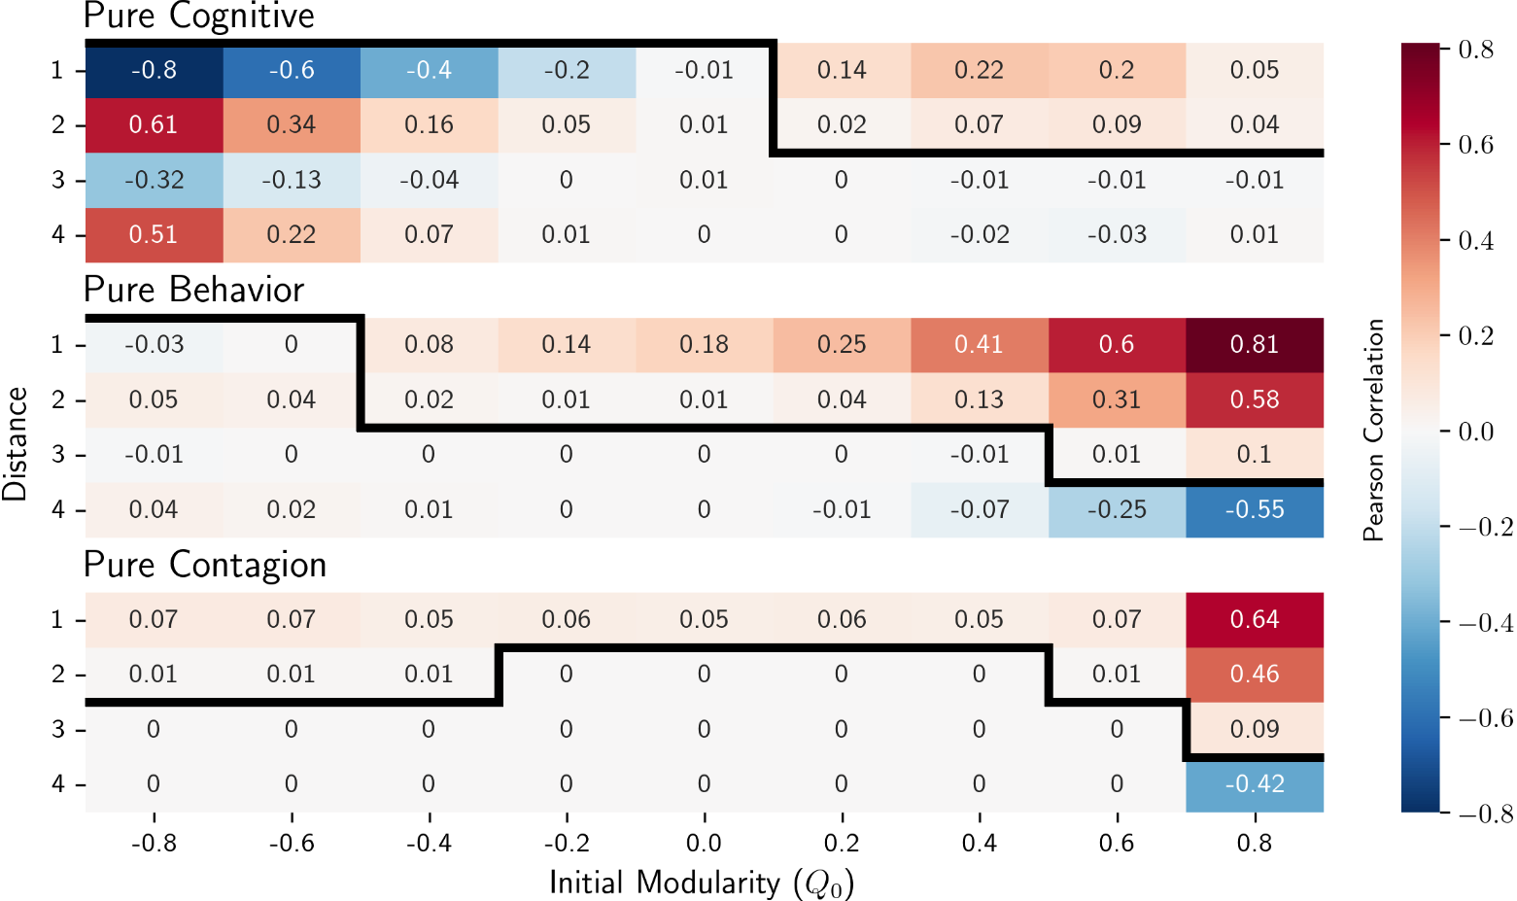

Figure 3: Correlation matrix illustrating the correlations over distance for each induction pathway at various initial modularity levels. The black line represents the maximum degree of influence (mDOI) for different levels of homophily and pathways. Each correlation value represents the mean correlation from 20 simulations.

Energy dynamics

We recover the result that the ego’s influence extends beyond direct connections and found up to three degrees of influence. The generalized nature of the mDOI metric under positive initial levels of homophily makes it challenging to differentiate between the various pathways and determine the causal mechanisms behind loneliness clustering based on it. Therefore, we analyzed the energy dynamics of each inductive pathway, individually and mixed, by examining the mean energy dynamics per subpopulation over time. Figure 6 displays the dynamics over time for each pathway, with line colors representing different initial levels of homophily. The first row depicts the energy development for each pathway acting alone over time. Each pathway demonstrates distinct dynamics. The cognition and emotional contagion pathways converge rapidly to equilibrium, but with notable differences. The emotional contagion pathway tends to converge towards the mean social energy, while the cognition pathway results in a shift of agents within each subpopulation, transitioning from high to low energy and vice versa. On the other hand, the behavioral pathway exhibits more complex behavior, influenced by the initial levels of homophily, which determines its convergence pattern.

The second row presents a scenario where one pathway is dominant, with 80% weight in the energy update process, while the remaining two are at 10%. When dominant, the cognitive pathway is not affected by the other pathways. When the behavior pathway is dominant, the cognition route still drives dynamics, except for the initially energetic subpopulation, which moves towards full energy. When looking at the dominant contagion pathway, the convergence rate is slowed. The third row illustrates the combination of two equally active pathways, with the cognitive pathway taking over the dynamics when equally mixed with the other two. When the contagion and behavioral pathways are equally mixed, the contagion pathway tends to pull the system toward the average energy values, except for when the initial level of homophily is high ($Q_{0}=0.8$). Here, there seems to be a tipping point in the level of homophily that tends to pull the system toward a fully energetic state.

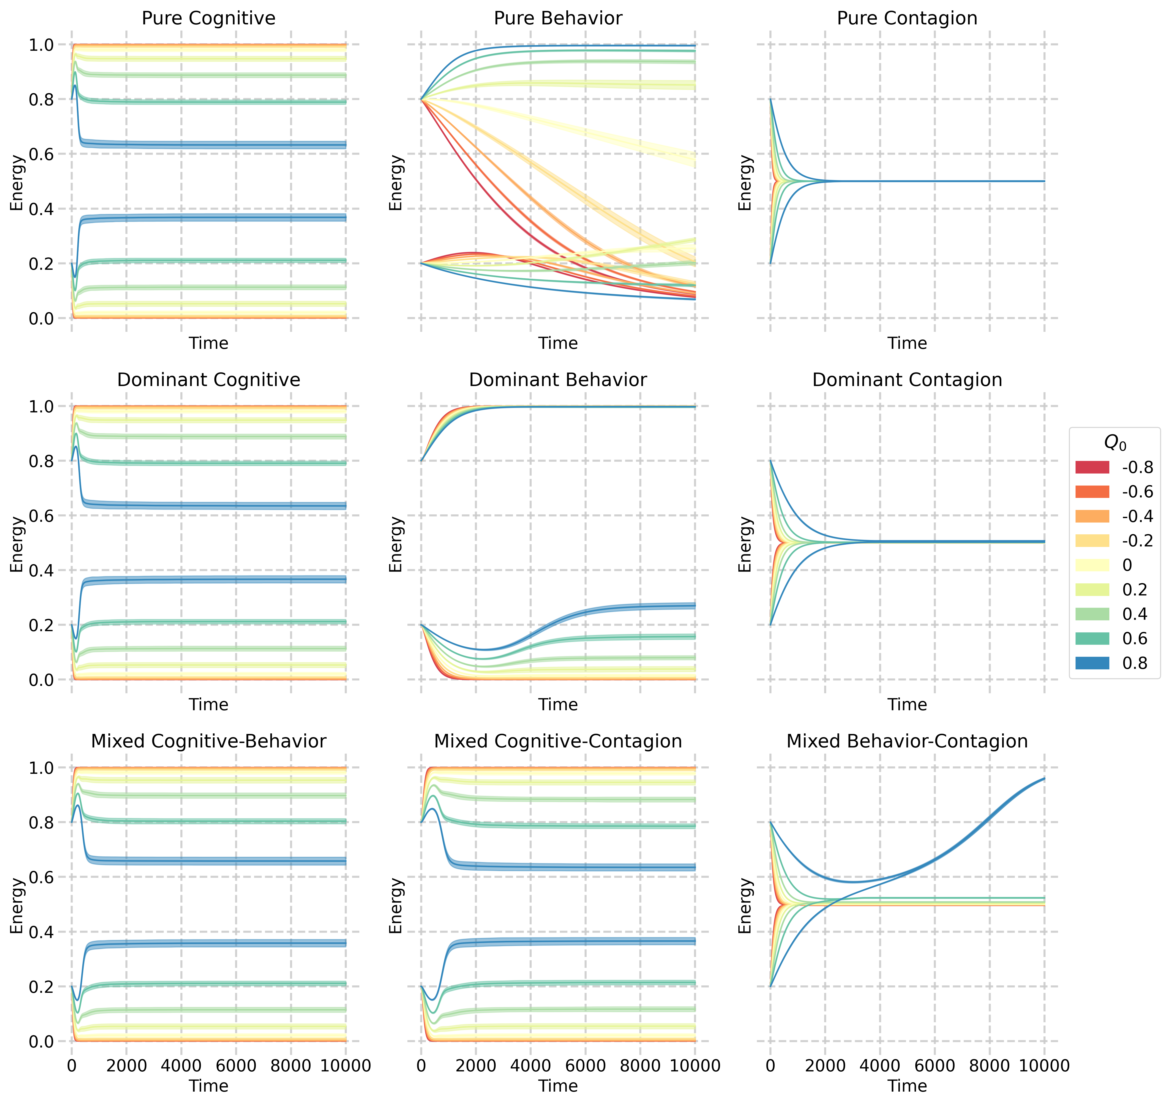

Figure 4: Mean energy dynamics per subpopulation over time for linear combinations of three inductive pathways. The line colors represent the starting modularity. Each pane presents the mean and standard error of the means based on 20 simulations. The first row displays the purely active pathway, the second row shows a 50/50 mix of two pathways, and the third row depicts a scenario where one pathway is dominant at 80% while the other two are at 10%.

Discussion

This study explores the interplay between homophily and inductive pathways in the clustering of loneliness within social networks. Our findings replicate the degrees of influence identified by [@cacioppoAloneCrowdStructure2009], suggesting that these influences are stronger in networks with increasingly positive initial levels of homophily ($Q_{0}>0$). These degrees of influence seem to emerge naturally, regardless of the underlying mechanisms or type of information being spread, which is further supported by [@pinheiroOriginPeerInfluence2014]. Therefore, while these influence metrics are significant system features, they do not provide meaningful insights for disentangling causal relationships deriving from different mechanisms.

Our findings indicate that the ability of inductive pathways to predict loneliness clustering is contingent upon a positive level of homophily. This aligns with prior studies showing how homophily fosters the formation of clusters or subgroups within larger social networks [@mcphersonBirdsFeatherHomophily2001a]leading to echo chambers, , and, ultimately, polarization[@lawrenceSelfSegregationDeliberationBlog2010]. Such polarization can potentially reinforce specific mental states, such as depression and loneliness [@xuHowDoesOnline; @wollebaekAngerFearEcho2019; @jesteBattlingModernBehavioral2020].

In our analysis of the energy dynamics of the inductive pathways, we can categorize them as self-activating (i.e., the cognition route), complex contagion (i.e., the behavior pathway), and simple contagion systems (i.e., emotional contagion). Internal cognitive processes and beliefs act as self-activating factors in the experience of loneliness [@akhter-khanUnderstandingAddressingOlder2022; @hawkleyLonelinessMattersTheoretical2010]. The cognition route also involves the emergence of loneliness based on individuals’ expectations and perceptions of their social lives compared to others. This dynamic gives rise to a bistable system with two attractor states: a lonely state and a non-lonely state. Similar bistable dynamics are hypothesized to exist in other mental health issues, such as depression [@cramerMajorDepressionComplex2016].

The behavior route involves inducing loneliness in others by exhibiting reduced trust and increased hostility once a loneliness threshold is surpassed [@hawkleyLonelinessMattersTheoretical2010]. This aligns with complex contagion, which requires a critical mass of individuals within ones social network to adopt the behavior for extensive spread [@lehmannComplexSpreadingPhenomena2018]. The network topology can affect the critical mass required to spread competing opinions as it is lowered in modular networks compared to random networks that lead to a faster and more extensive spread of the behavior [@vasconcelosConsensusPolarizationCompeting2019]. Furthermore, the convergence speed is affected by the changes in modularity as wide bridges (i.e., many connections between communities) tend to speed up complex contagion as opposed to long bridges (i.e., few links formed with weak ties belonging to another community) having the opposite effect [@centolaComplexContagionsWeakness2007]. Therefore, future research should include sampling more initial network topologies and examining their effects over different levels of modularity using the provided methodology.

Lastly, the emotional contagion pathway operates through a simple contagion process where non-verbal communication spreads and aligns mental states. Simple contagion involves spreading behaviors or beliefs with a single exposure or reinforcement. Emotional contagion occurs through the transmission of non-verbal cues and expressions, leading to a convergence of emotional states. This is consistent with the [@degrootReachingConsensus1974] model that describes information or behavior spread through social influence. We find that in this pathway, modularity tends to slow down the spread of the contagion by limiting connections between different communities which is in line with literature [@centolaSpreadBehaviorOnline2010; @wengViralityPredictionCommunity2013]. Excessive/high homophily confines the contagion to individual communities, while inadequate modularity allows for rapid and widespread diffusion that saturates the entire network [@lehmannComplexSpreadingPhenomena2018].

Our modelling results point at the cognition and emotional contagion pathways as the main determinants of dynamical behavior over short and long periods. Each pathway exhibits unique energy dynamics, but the interaction between pathways complicates the identification of individual trajectories and the assessment of causal contributions. To gain insights into the underlying processes contributing to loneliness clustering, future research could observe naturally perturbed real-world systems or investigate the formation of social networks based on subjective perceptions of loneliness, as explored by [@fridmanskiClusteringNewlyForming2020], where they aimed to investigate whether first-year college students form social networks based on subjective perceptions of loneliness.

Our study has several strengths. Firstly, we have developed a method that enables systematic sampling of homophily levels while maintaining the population’s degree distributions. We were the first to use such an ABM to replicate the relevant clustering hypotheses on loneliness, which we partly confirmed. Future research should investigate the consequences of our homophilic network generation procedure, including changes in triadic closure and modularity through community detection, which might cause unforeseen interactions concerning homophily that could drive the observed dynamics [@asikainenCumulativeEffectsTriadic2020]. Additionally, the simplicity of our model allows for assessing the interplay between homophily and induction with its three different causal pathways. However, our study also has several limitations, as we focused exclusively on heterogeneity related to connections and their influence on the evolution of dynamical states. We neglected other forms of heterogeneity that could be explored, such as different environmental influences as shared environments among individuals may play a significant role in cluster formation in social networks [@sawirLonelinessInternationalStudents2008; @segrinFamilyOriginEnvironment2012], and omitting this aspect could overemphasize the importance of homophily and induction. Investigating the role of heterogeneity in future work is essential, but caution must be exercised as it could obscure structural understanding [@reeves2022structural]. Furthermore, the three induction pathways in our model are linear combinations of each other, and a non-linear schema might provide a more accurate fit.

Future research could address these limitations by exploring more complex models that better capture the dynamics of real-world social networks. For example, validation using social network data containing loneliness data over time could help to calibrate and validate our model and its extensions. In addition, by understanding the inductive pathways and the role of homophily in social networks, future research could quantify these inductive influences on a per-person level. Finally, interventions that target specific individuals within social networks, such as agents who are always at maximum energy or targeted rewiring methods, could be tested to determine their effectiveness in reducing loneliness in the network. For example, this model could be used to test [@cacioppoAloneCrowdStructure2009] suggestion that interventions to reduce loneliness may benefit from targeting people on the periphery of a social network to help repair their social connections. Doing so may create a protective barrier against loneliness, keeping the whole network from unraveling.

Our study provides insights into the social nature of mental pathology and the role of inductive pathways in developing loneliness clustering in social networks. It underscores the role of existing homophily in social networks as a supportive platform for inductive processes. As such, mental health cannot be fully understood by examining individual-level factors alone but must be situated within the broader social context in which it occurs. By doing so, we can develop a more nuanced understanding of the causes and consequences of mental health issues and develop more effective interventions to address them.

Appendix A: Extended Methods

Henceforth, we will use the following notations in table [tab:notations] to denote the concepts used in this paper.

| **Notation** | **Explanation** |  |  |  |
| --- | --- | --- | --- | --- |
| $$i$$ | Node/agent identification index. |  |  |  |
| $$j$$ | Node/agent identification index of node initiating relationship towards $i$. |  |  |  |
| $$e_{i}$$ | Energy level of agent $i$, an abstraction of the amount of energy one has to engage in social activity and used as a proxy for loneliness in our model. |  |  |  |
| $$k_{i}$$ | Connectivity level of agent $i$, an abstraction of the how connected the agent feels to their social surroundings. |  |  |  |
| $$⟨e_{j}⟩$$ | Average energy taken over the incoming neighborhood nodes. |  |  |  |
| $$\deg_{i}^{+}$$ | Out-degree, or number of outgoing relationships of node $i$. |  |  |  |
| $$\deg_{i}^{-}$$ | In-degree, or number of incoming relationships of node $i$. |  |  |  |
| $$β$$ | Connectivity decay rate. |  |  |  |
| $$ρ$$ | Pearson correlation, or the assortativity, of the network for the energy property. Used to quantify induction effects by measuring the clustering of energy in the network. |  |  |  |
| $$Q$$ | Modularity, the metric used to quantify homophily based on fixed labels of subpopulations. |  |  |  |

Operationalisation of homophily

The model incorporates homophily by converging a network to a fixed state of modularity ($-1≤Q≤1$). First, two identical Barabasi-Albert subpopulations are created that only differ in initial energy. The resulting network exhibits a complete separation of relationships between these subpopulations, maximizing modularity. To achieve the desired initial modularity, the initial connections are indexed in each subpopulation and paired with identical counterparts in the other subpopulation. These pairs are then randomly rewired, introducing entropy into the system while preserving the degree distribution. This iterative process facilitates the network’s progressive convergence towards modularity of -1, encompassing all intermediate values during the transition. Figure 7 provides a visual representation of this process, while figure 8 provides a representation depicting the interconnectedness of the subpopulations over different initial modularities.

The resulting initial topology remains fixed throughout the simulation. Eliminating relationship formation, strengthening, and dissolution from the model reduces the need for additional nontrivial assumptions. Moreover, separating homophily from induction enables us to evaluate the dominant mechanism in the system and how these two mechanisms interact, as we can initiate networks with various modularity values.

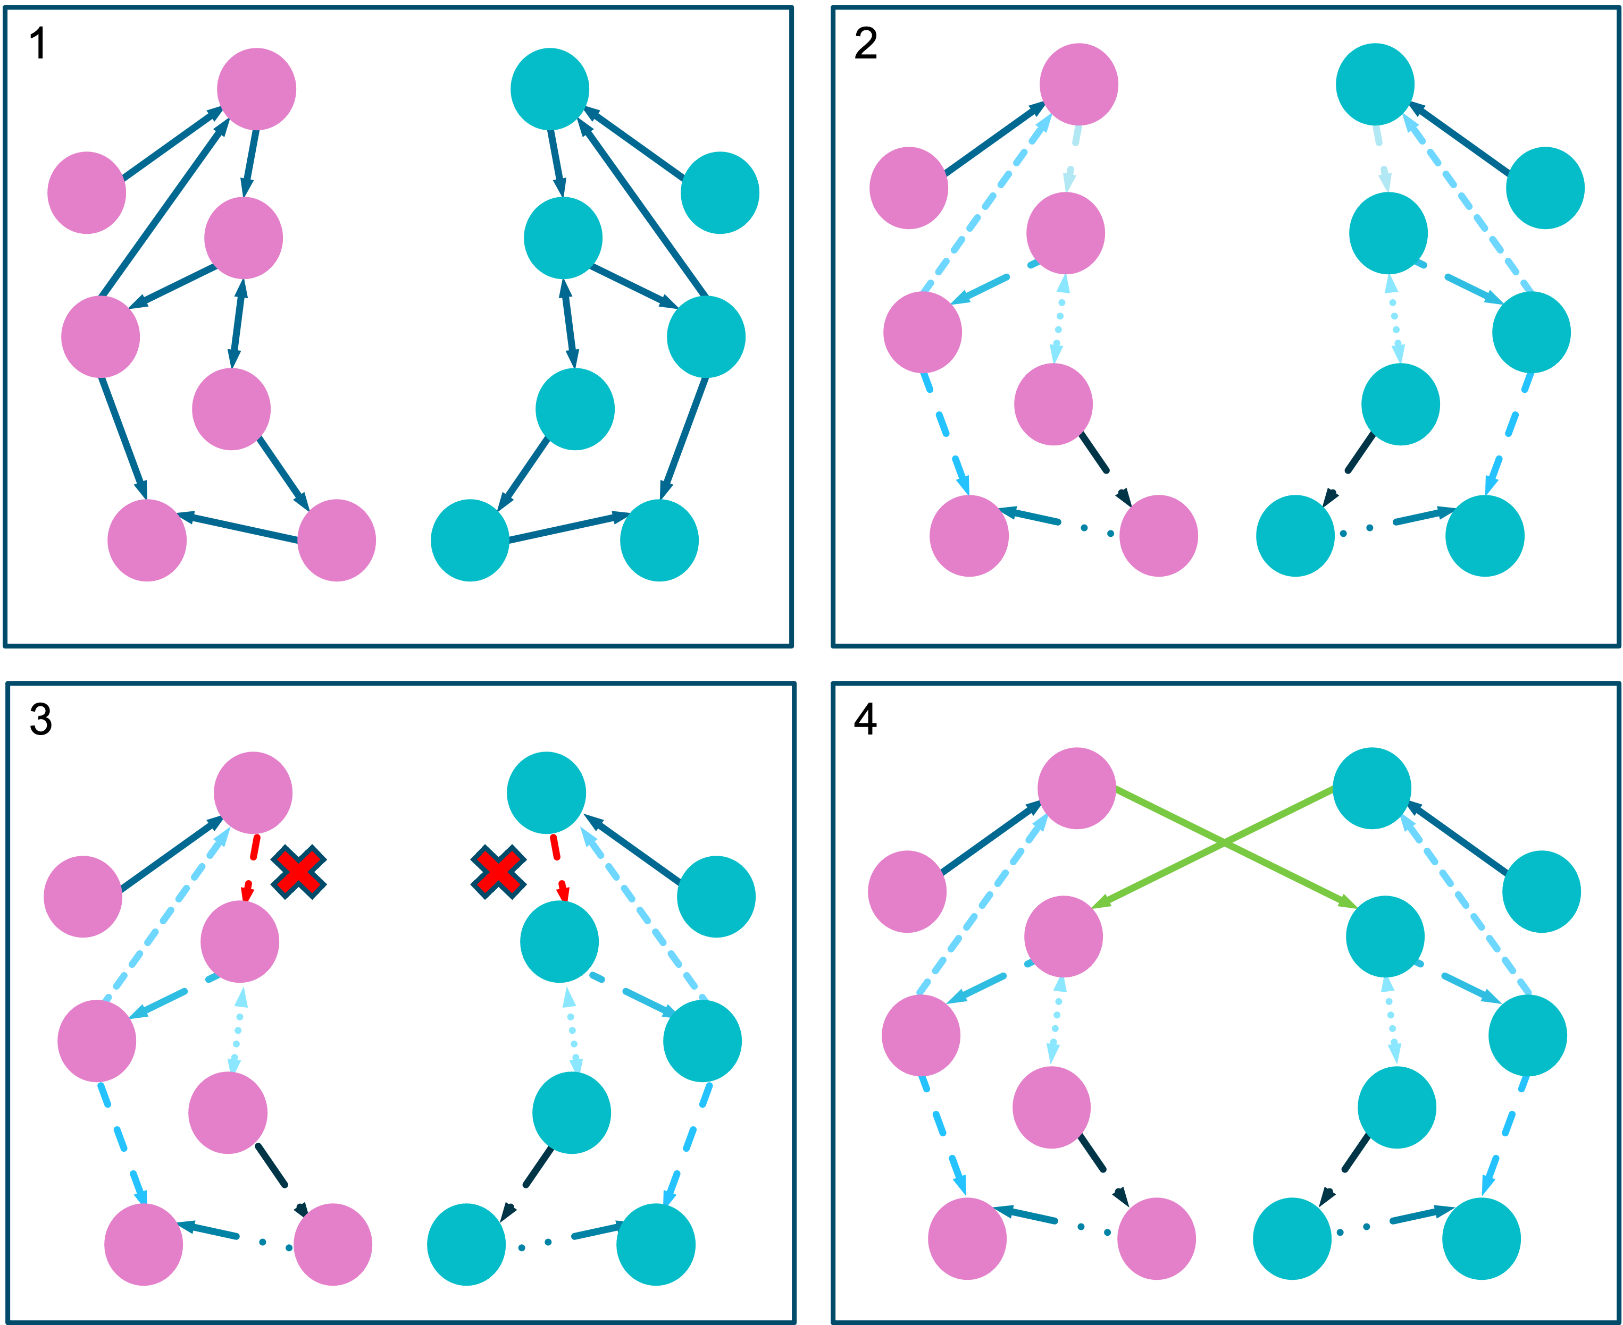

Figure 5: Schematic representation of a single iteration of the rewiring method. Two identical graphs are used as subpopulations (N=500) with differing initial social energy. Identical links are paired up, and a random pair is selected for link removal. The removed link is then redirected to the other subpopulation.

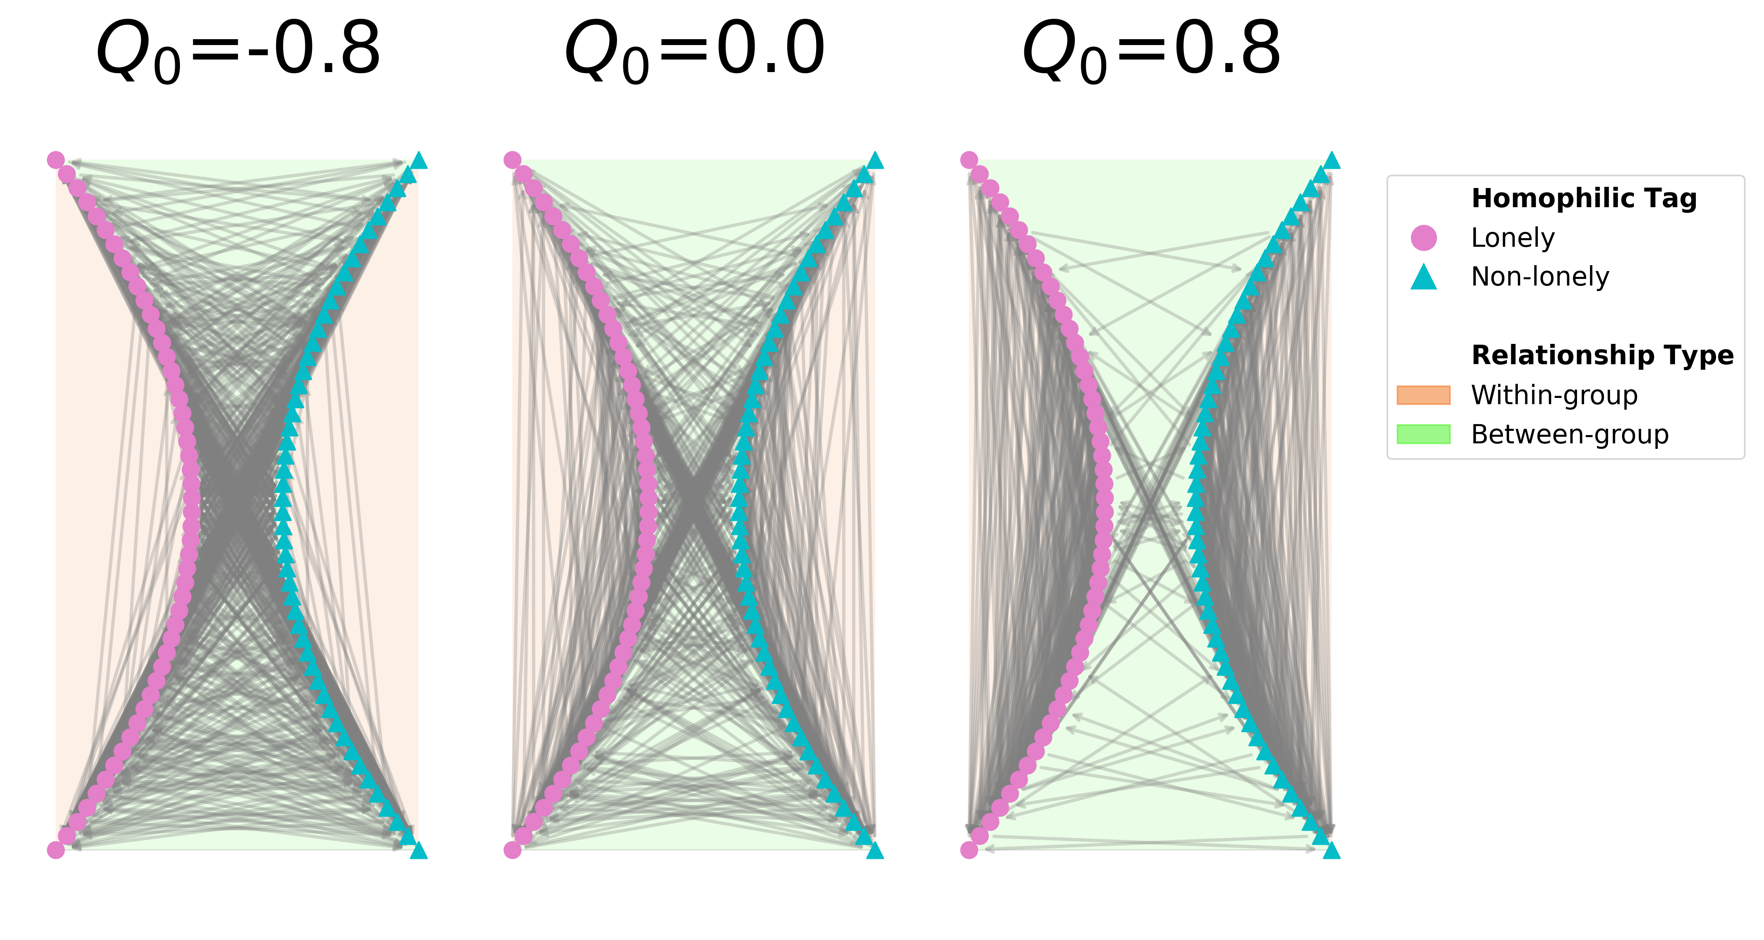

Figure 6: The network representation illustrates negative ($Q_{0}=-0.8$), neutral ($Q_{0}=0$), and positive ($Q_{0}=0.8$) modularity. Within the diagram, the red-shaded areas represent connections within groups, indicating relationships among nodes with similar attributes. Conversely, the blue-shaded areas represent connections between groups, denoting relationships among nodes with differing attributes. In addition to the shading, the nodes in the network exhibit different colors and shapes, signifying distinct homophilic tags.

Operationalisations of the induction pathways

We describe the different pathways from an individual perspective, but individuals are embedded in a social network. Let $a_{ij}$ be an adjacency matrix that identifies whether individual $i$ is connected to individual $j$, for which case $a_{ij}=1$, or they are not connected, $a_{ij}=0$. At each time point, $t$, individuals update their internal state, including their social energy, $e_{i}^{t}$, based on different pathways. For convenience, we will ignore the time superscripts whenever it is unnecessary to specify the time point.

Cognitive

The cognitive pathway states that loneliness is affected by a discrepancy between the expectation and the perception of one’s social network. Interactions with others influence these expectations of what it means to have ideal social connectivity.

We have operationalized this process as an interplay between the social energy of individual $i$, $e_{i}$, and perceived connectivity with one’s own social network, $k_{i}$. The change in that perceived social connectivity is given by

$$k_{i}^{t+1}-k_{i}^{t}=e_{i}^{t}-k_{i}^{t}β.$$

In this system, $β$ represents the rate at which a person’s social connectivity decays over time without sufficient social energy to maintain it. The intuition is that social relationships can have a natural decay and that energy needs to be put into maintaining them. Specifically, if a person’s social energy is low ($e_{i}<k_{i}β$), their perceived social connectivity will decrease, and unless $e_{i}$ increases, $k_{i}$ will keep decreasing. A higher beta value implies a faster decay rate, meaning that a person’s perceived social connectivity will decrease more rapidly over time without sufficient social energy. Conversely, a lower beta value implies a slower decay rate, meaning that a person’s perceived social connectivity will decrease more slowly over time without social energy. If a person’s social energy is high ($e_{i}>k_{i}β$), perceived social connectivity will increase.

Social connectivity feeds back into social energy. The change in social energy of an agent $i$ is determined by $f_{i}^{c}$ in Eq.([eq:cognition]), the difference between the perceived social connectivity and the mean perceived social connectivity of the agent in node $i$’s neighborhood, denoted by. It represents the deviation of node $i$’s perceived social connectivity from the average connectivity of its neighbors (i.e., a proxy for expectations based on its neighbors).

$$f_{i}^{c}=k_{i}-⟨k_{j}⟩_{i}$$

Behavioral

Individuals experiencing loneliness may display less trusting and more hostile behaviors toward others. These behaviors can negatively impact relationship satisfaction and may result in the loss or weakening of the relationship, subsequently inducing loneliness in others. To formalize this process, we propose that the change in social energy of an agent $i$ via the behavior pathway, $f_{i}^{b}$, follows

$$f_{i}^{b}={\left\langle \frac{e_{j}-θ}{d_{j}^{+}}\right\rangle }_{i}e_{i},$$

where ${\left\langle \frac{e_{j}-θ}{d_{j}^{+}}\right\rangle }_{i}$ is the average social energy contribution from neighboring nodes $j$ to $i$, calculated based on the number of others that $j$ divides its time on (i.e., its out-degree),. An agent with a small out-degree can allocate more energy to node $i$, leading to a greater contribution. The value $θ$ represents a threshold point at which an agent is considered lonely and may exhibit less trusting and more hostile behavior, contributing negatively to the social energy of its neighbors.

Further, the energy of the focal node $i$, $e_{i}$, scales the effect above. This allows node $i$ to modulate the impact of others based on its energy level, as individuals may exhibit "less trusting and more hostile" behaviors as energy levels decline. The value of $e_{i}$ acts as a regulator, down-regulating the effect of others on the individual as the individual becomes less receptive to others.

Emotional contagion

Individuals can experience a convergence of emotions through nonverbal communication. For example, loneliness can lead to shyness, social awkwardness, and hostility towards socially ambiguous cues, which could contribute to others in their immediate environment also experiencing loneliness. Emotional contagion is the "tendency for the facial expressions, vocalizations, postures, and movements of interacting individuals to lead to a convergence of their emotions" [@cacioppoAloneCrowdStructure2009]. To model this process, we assume that agents converge towards the mean energy for the emotional contagion pathway upon interaction.

The change in social energy of node $i$ due to this process is given by the average social energy of the neighbors relative to that of the self:

$$f_{i}^{ec}=⟨e_{j}⟩_{i}-e_{i}$$

In this equation, represents the mean energy of the neighborhood of node $i$. This implies that agents converge toward the mean energy of their neighborhood when they interact with others.

Combining pathways

These pathways combine linearly to determine an individual’s social energy. The following equations summarize the system:

$$\begin{matrix}k_{i}^{t+1}-k_{i}^{t} & =e_{i}^{t}-k_{i}^{t}β \\ e_{i}^{t+1}-e_{i}^{t} & =\left(\left(p_{1}f_{i}^{ct}+p_{2}f_{i}^{bt}+p_{3}f_{i}^{ect}\right)+\text{norm}\left(μ,σ\right)\right) e_{i}^{t}\left(1-e_{i}^{t}\right)\end{matrix}$$

In our model, we have the equation $p_{1}+p_{2}+p_{3}≡1$, where $p_{1}$, $p_{2}$, and $p_{3}$ represent the three induction pathways. To account for inherent uncertainties and randomness, a noise term $\text{norm}\left(μ,σ\right)$ is added with $μ=0$ and $σ=0.02$. Additionally, the function $e\left(1-e\right)$ constrains the social energy level within the range of 0 and 1, ensuring a realistic representation of the system’s dynamics.

Parameter values

| **Parameter** | **Symbol** | **Value** | **Comment** |  |
| --- | --- | --- | --- | --- |
| Population size | $$N$$ |  | Number of agents in the simulation. |  |
| Simulation duration | $$T$$ |  | Simulation duration in timesteps. |  |
| Number of edges per new node | m |  | Number of edges to attach from a new node to existing nodes in Barabasi-Albert algorithm. |  |
| Decay parameter | $$β$$ | .5 | Decay strength of social connectivity. |  |
| Initial Modularity | $$Q_{0}$$ | $$-1≤Q_{0}≤1$$ | Metric of homophily measuring the interconnection between subpopulations in the initial network. |  |

Appendix B: Extended results

Kernel Density Estimations of correlation distributions

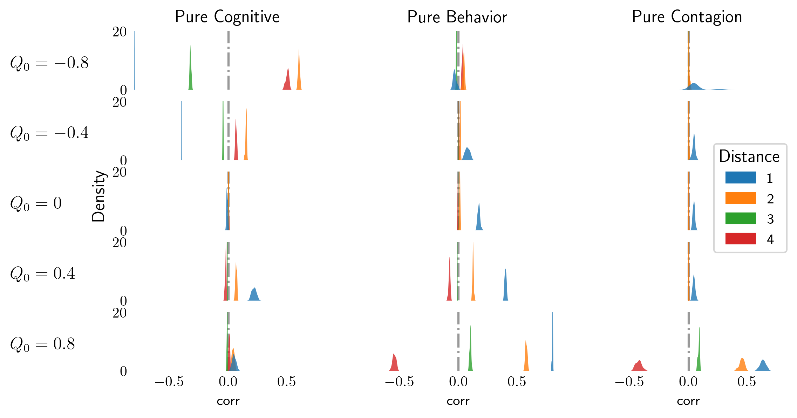

Figure 7: Kernel Density Estimations of correlation distributions for each pathway over different initial modularities. Each distance is plotted separately and colored accordingly. We can see that distribution estimations are narrow and increase as $Q_{0}$ increases.

Degrees of influence over time

|  |  |  |  |
| --- | --- | --- | --- |
| Pure Cognitive | Pure Behavior |  | Pure Contagion |

Figure 8: 10), 11), and 12) illustrate the maximum degree of influence (mDOI) for different starting levels of homophily values and pathways over time (i.e., timestep 100, 1.000, and 10.000), providing insights into the stability of the clustering behavior in the network. The pure contagion and behavioral pathways display positive mDOI at negative initial modularities after 1000 timesteps, while the pure contagion pathway initially increases over simulation time while decreasing after convergence. Error bars indicate standard errors of the mean based on 20 simulations.

Sensitivity of network size

<TODO> Just waiting for data to finish generating.

Sensitivity of noise parameter

<TODO> Just waiting for data to finish generating.